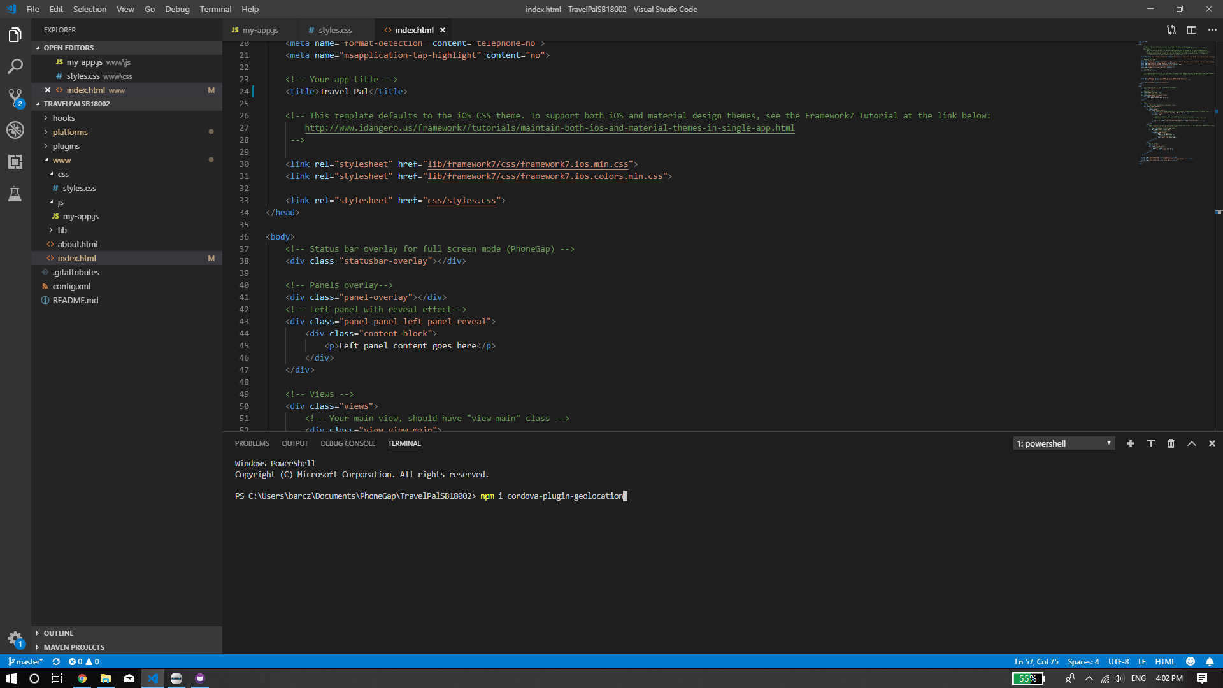

Mobile Development

Module Title: Mobile Development Assignment
Type: Individual Practical Project Project
Title: Travel Pal
Project Date: 25 th February 2019
Assignment Compiler:
Amilcar Aponte
Weighting: 50% Due
Date: 28th April 2019
Method of Submission: Moodle Submission

